Daniel Meyer

0405182

CSIS 202-1008

**Midterm Essay**

When creating a design for a network to connect a university and its four satellite campuses, three aspects need to be kept in mind: the infrastructure of each system in the network, linking each system to the primary system, software needed to do so, and cost. For the infrastructure of each system (campus in this case), a centralized data center will be used to send data from local users (physically nearby) to the primary system (the University in this case) using Border Gateway Protocol (BGP). Each connected system would be interconnected using Cisco’s ONE server software allowing for communication between each other. Finally, costs would be recovered via charges to students for network access allowing for the system to pay for itself and funds to be generated for further expansion in the future.

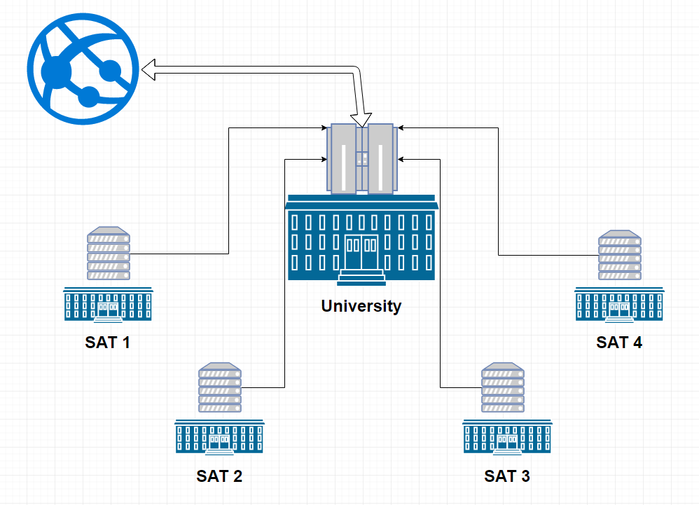Due to each of the campuses having a high density of users simultaneously connected to the network, two setups are needed to effectively manage incoming and outgoing data. For each of the satellite campuses a centralized server acting as a gateway to the University will be supplied with Cisco Systems, Inc. switches. This will allow users whom are connected to local routers, which are connected to the switches, to communicate with the University, other satellite campuses, and the Internet. Each user will connect to routers placed in dormitories and school buildings across each campus that route information via an Open Shortest Path First (OSPF) routing protocol to the server for that campus. From the server, the data will be routed to the main backbone of the system located at the University via BGP, and from there, connect to the rest of the world. At the core of this system, the University, will have a larger central switch system to act as the backbone of the system’s entirety. Here the University will handle communications with the Internet and host the school’s domain name server. With this multi-setup system, information can be monitored for security to protect the network’s entirety, congestion can be managed, and communication within the network doesn’t need to be sent to the internet and retrieved again, allowing for local (within the network) communication.

This network configuration will be held together using Cisco’s ONE for WAN and ONE for Access software. Using ONE for WAN for the University will allow for each satellite campus to appear as a local connection within the network. It will also allow for communication between the University and individual campuses with the Internet. ONE for Access, on the other hand, will be used to allow students and staff to connect their devices (i.e. tablets, phones, computers) to the network. ONE for Access manages the connections between each individual router and their switch for the campus they are located at. Included with both ONE for WAN and ONE for Access is the Cisco Software Support Service giving full-time support for the network in the case of a failure. Each device of each user will need to be assigned an individual IP address. For this a subnet will need to be configured for each router within each campus.

Ultimately however, the design has to be cost-effective. The design presented in this document provides minimal cost with maximum effectiveness. By centralizing the network at the University, only a singular mainframe is needed to manage the individual links at each of the four satellite campuses. The centralization also provides simpler means for controlling traffic to and from the internet, and traffic between each campus. Furthermore, the need for stronger cabling (i.e. fiber optic lines) is only present at the University where the majority of traffic is present instead of at each individual campus. Initial cost though isn’t the only concern. The investment needs to pay itself off at some point in time. A solution to this would be to charge students a fee to have access to the network for those who wish to subscribe to the campus’ Internet. The price to charge for each student can be found using the following equation:

$ / student = (Total Cost / Years to Pay Off) / Total Number of Students

This presents a way to get a return on the investment as well. After the years pass, a consistent revenue stream from those paying to access the network will allow for money to be placed aside for future expansions and/or upgrades needed to be made to the network.

This design presents a centralized design in which users and devices can interact within the network without the need to send data outside of the network, as well as interact with those beyond the network. Using BGP, the mainframe located at the University allows for communication between each campus’s system over links provided by Cisco Systems, Inc. OSPF allows for communication between routers within each campus. Meanwhile, ONE for WAN allows for the interaction between campuses and ONE for Access allows for users to access the network’s routers. The network for connecting a University and its four satellite campuses to one another and the internet was designed to be both economical, and effective.